HAVE A GO FOLEY-OKE
Jack Foley initially worked in the Silent Movie industry. When sound was introduced, he became involved in developing filmmaking sound effect techniques, one of which was unique in that sound effects were performed live during a film’s post-production stage, using everyday accessible items. Foley Sound Effects are still widely practised today,anyone working in this trade is known as a Foley Artist.

At various stages of our animation, we include the following black & white graphic texts, and have described how each one was produced for you, in order that you too, can have a go. Some are more obvious than others:

1 A parade of lanterns (sea creatures) goes over a bridge above a river during the Festival of Light (Gwyl Goleuadau), following drumming sounds. Make your own rhythms by tapping sticks on a table or blank canvas.

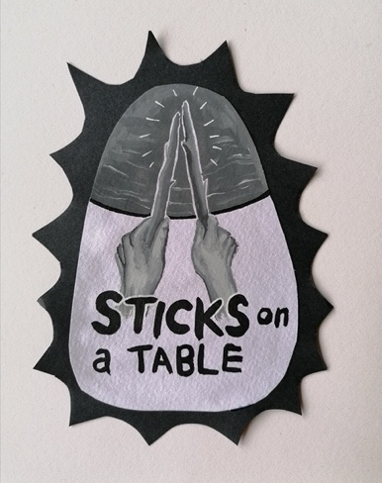

2 A Sea Salmon (Eog Mor), swims through various activities, moving in and out of water. To make a SPLASH drop some stones in a bowl of water.

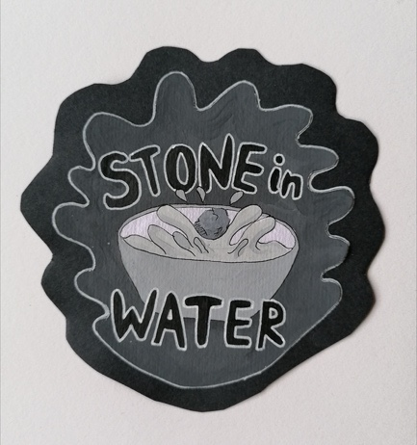

3 & 4 A Seagull (Gwylan) swoops from the sky as the Salmon (Eog) flaps in a flooded field. Flap your dishwashing gloves quickly or slowly to make the sound of a flying bird. Then tap/splash water on a plate to make the sound of the Sea Salmon flapping around in the flooded field.

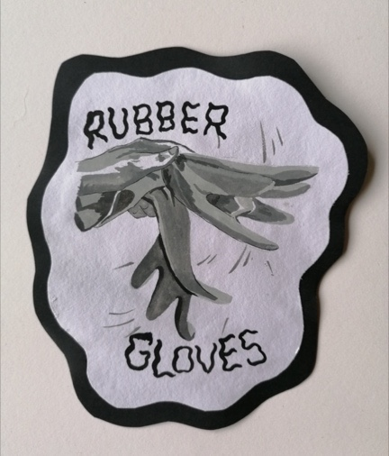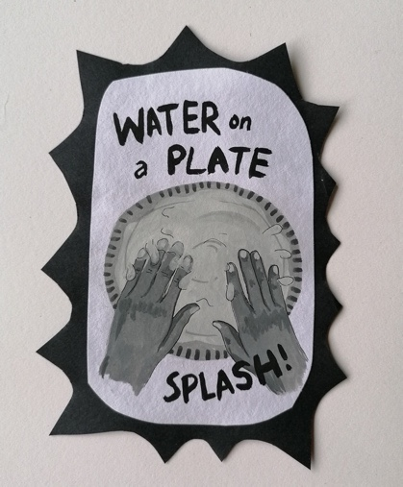

5 Two owls feature in our animation – 1 at the Festival of Light (Gwyl Goleuadau), the other at a Halloween event (Calan Gaeaf). Cup your hands over your mouth, purse your lips as though you’re about to whistle and repeat a whoo whoo sound. Interesting fact! When you hear an owl say too-whit too-whoo, it’s actually two owls communicating, 1 says too-whit, the other replies too-whoo!

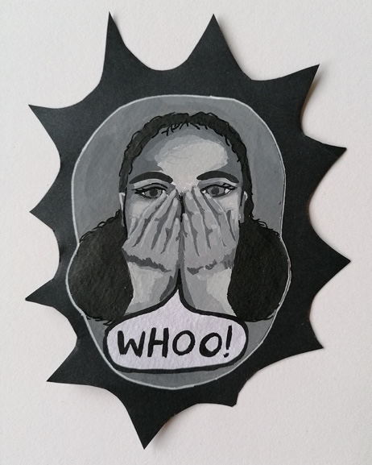

6 On two occasions, tea cups appear within our illustrations. This was an easy sound effect to make as we just chinked a metal spoon on the side of a china teacup.

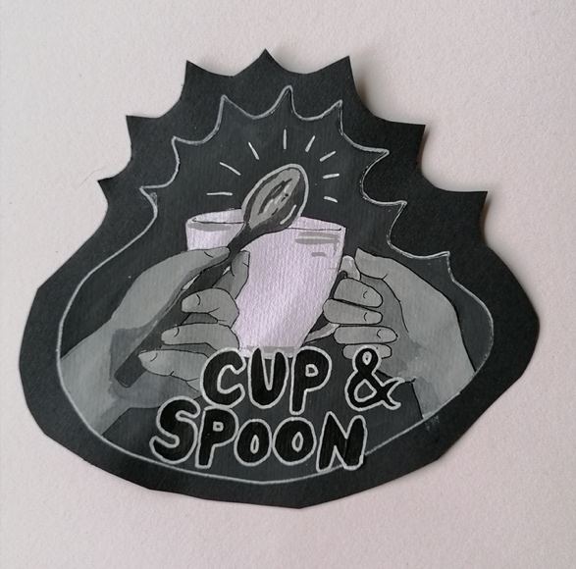
7 Rosie Riveter features during Wartime Bridgend. To make it sound like Rosie was working in a factory, we played with metal screws and coat hooks, dropping them and moving them around in a glass pot and on a table.

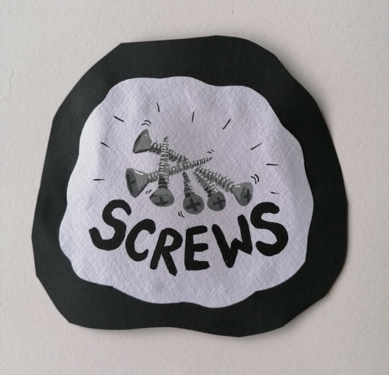

8 The Wartime Bridgend events in June, often include vintage wartime vehicles. Our animation features the propeller of an old airplane. Before you take your dog for a walk, make sure you have enough space around you to safely spin the lead around as quickly as you can to emulate the sound of the propeller. DISCLAIMER! Please be careful not to hit yourself or anyone else in the process!

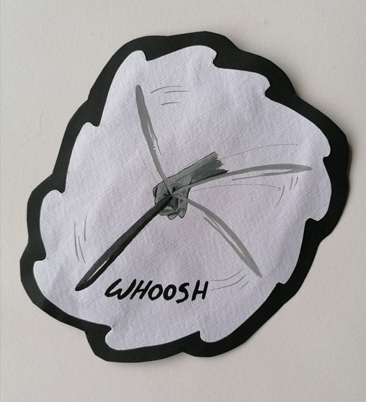

9 For our classic Christmas Jingling Bells (Clychau Nadolig), we used 3 little tin bells that I hang on my tree!

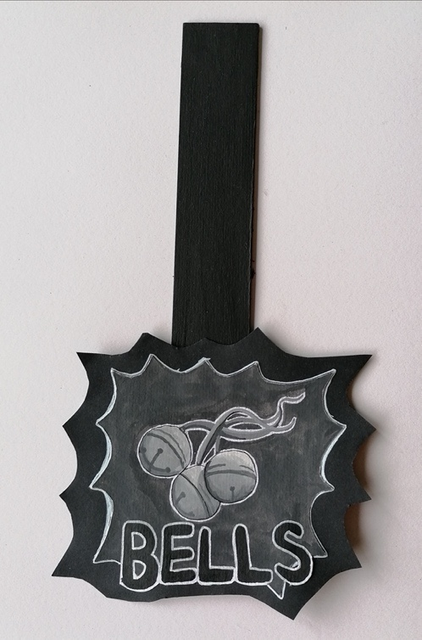

EXTRA BONUS SOUND EFFECT:

Frying bacon sounds like rain!

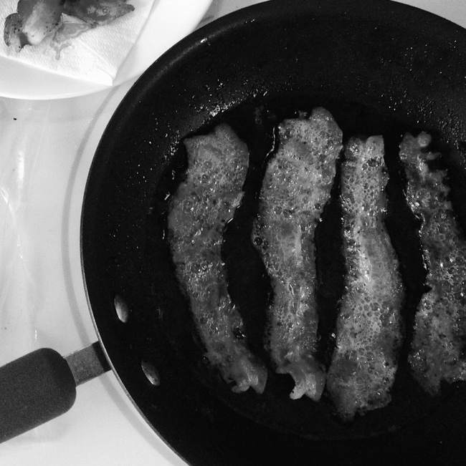

Have fun making your own Foley sound effects!
ENJOY
MWYNHEWCH
Claire & Carys.

